## Vivekanand Education Society’s Institute of Technology,

**(An Autonomous Institute affiliated to University of Mumbai)**

**Department of Computer Engineering**

# 

# CarboNeutral

# Submitted in partial fulfillment of the requirements of the degree

## BACHELOR OF ENGINEERING IN COMPUTER ENGINEERING

# By

# Dhara Bhatia D12C/ 09

# Chiraag Chugh D12C/13

# Sonnal Katara D12C/32

# Neha Lotwani D12C/41

# 

# Name of the Mentor

# Mrs. Priti Joshi

# University of Mumbai

# (AY 2023-24)

# 

## Vivekanand Education Society’s Institute of Technology,

**(An Autonomous Institute affiliated to University of Mumbai)**

**Department of Computer Engineering**



# CERTIFICATE

This is to certify that the Mini Project entitled **“CarboNeutral: building a greener, more resilient planet for generations to come”** is a bonafide work of **Dhara Bhatia (D12C-9), Chiraag Chugh (D12C-13), Sonnal Katara (D12C-32), Neha Lotwani (D12C-41)** submitted to the University of Mumbai in partial fulfillment of the requirement for the award of the degree of **“Bachelor of Engineering”** in **“Computer Engineering” .**

**(Mrs. Priti Joshi)**

Mentor

##### (Prof. Dr. Nupur Giri) (Prof. Dr. J.M.Nair)

Head of Department Principal

# Mini Project Approval

This Mini Project entitled “**CarboNeutral: building a greener, more resilient planet for generations to come”** by **Dhara Bhatia (D12C-9), Chiraag Chugh (D12C-13), Sonnal Katara (D12C-32), Neha Lotwani (D12C-41)** is approved for the degree of **Bachelor of Engineering** in **Computer Engineering.**

**Examiners**

**1………………………………………**

(Internal Examiner Name & Sign)

##### 2…………………………………………

(External Examiner name & Sign)

Date:

Place:

**DECLARATION**

We declare that this written submission represents our ideas in our own words and where others' ideas or words have been included, we have adequately cited and referenced the original sources. We also declare that we have adhered to all principles of academic honesty and integrity and have not misrepresented or fabricated or falsified any idea/data/fact/source in our submission. We understand that any violation of the above will be cause for disciplinary action by the Institute and can also evoke penal action from the sources which have thus not been properly cited or from whom proper permission has not been taken when needed.

| -----------------------------------------  (Signature)  -----------------------------------------  (Dhara Bhatia D12C-09) | -----------------------------------------  (Signature)  -----------------------------------------  (Chiraag Chugh D12C-13) |
| --- | --- |
| -----------------------------------------  (Signature)  -----------------------------------------  (Sonnal Katara D12C - 32) | -----------------------------------------  (Signature)  -----------------------------------------  (Neha Lotwani D12C - 41) |

Date:

# 

# ACKNOWLEDGEMENT

We are thankful to our college Vivekanand Education Society’s Institute of Technology for considering our project and extending help at all stages needed during our work of collecting information regarding the project.

It gives us pleasure to express our deep and sincere gratitude to **Mrs. Priti Joshi** (Project Mentor) for her kind help and valuable advice during the development of project synopsis and for her guidance and suggestions.

We are deeply indebted to the Head of the Computer Department, **Dr.(Mrs.) Nupur Giri** and our Principal **Dr. (Mrs.) J.M. Nair**, for giving us this valuable opportunity to do this project.

We express our hearty thanks to them for their assistance, without which it would have been difficult to finish this project synopsis and project review successfully. We convey our deep sense of gratitude to all teaching and non-teaching staff for their constant encouragement, support and selfless help throughout the project work. It is a great pleasure to acknowledge the help and suggestion, which we received from the Department of Computer Engineering.

We wish to express our profound thanks to all those who helped us in gathering information about the project. Our families too have provided moral support and encouragement several times.

# Contents

**Index**

**Title Page no.**

**Abstract 01**

**Chapter 1: Introduction 02**

1.1 Introduction

1.2 Motivation

1.3 Problem Definition

1.4 Existing Systems

1.5 Lacuna of the existing systems

1.6 Relevance of the Project

**Chapter 2: Literature Survey 06**

2.1 Brief Overview of Literature Survey

2.2 Research Papers Referred

a. Abstract of the research paper

b. Inference drawn

2.3. Inference drawn

2.4 Comparison with the existing system

**Chapter 3: Requirement Gathering for the Proposed System 10**

3.1 Introduction to requirement gathering

3.2 Functional Requirements

3.3 Non-Functional Requirements

3.4.Hardware, Software , Technology and tools utilized

**Chapter** 4**: Proposed Design 13**

4.1 Introduction to the System

4.2 Architecture Framework/Conceptual Design

4.3 Process Design

4.4 Methodology Applied and Algorithms

**Chapter 5: Testing of the Proposed System 17**

5.1. Introduction to testing

5.2. Types of tests Considered

5.3 Various test case scenarios considered

5.4. Inference drawn from the test cases

**Chapter 6: Implementation 20**

6.1. Screenshots of User Interface (UI) for the respective module

6.2. Performance Evaluation measures

6.3. Input Parameters / Features considered

**Chapter 7: Conclusion 24**

7.1 Conclusion

7.2 Future Scope

7.3 References

**Reference 26**

**Paper Published 27**

**Plagiarism Report 34**

**Project Review Sheet 35**

### Abstract

All living and nonconscious things are a section of the scheme because of a rise within the range of vehicles, rapid population growth and industrialization over the years, the carbon content within the atmosphere has risen at an associate degree exponential rate. Transportation, Industrialization and technological growth are beneficial to the modern world but are major concerns generating carbon footprint.

A carbon footprint is a measure of the total amount of greenhouse gas emissions (primarily carbon dioxide) that are generated by an individual, organization, or activity over a given period of time, usually expressed in metric tons of carbon dioxide equivalent (CO2e).

Calculating and reducing one's carbon footprint has become an important aspect of environmental awareness and sustainable living.

The CarboNeutral application will help an organization reduce their carbon footprint and maintain an eco-friendly business environment.

### Introduction

* 1. **Introduction**

CarboNeutral is a valuable tool that can help individuals and organizations understand their carbon emissions and identify ways to reduce them. By calculating the ratings of various activities, such as transportation, energy usage, and food consumption, users can gain insight into the environmental impact of their daily choices and make informed decisions about how to reduce their environmental impact. The term 'carbon footprint' encapsulates the total amount of greenhouse gases, particularly carbon dioxide, that an individual, organization, or activity is responsible for emitting into the atmosphere. It serves as a vital measure of our collective impact on the environment and plays a pivotal role in addressing global climate change. Understanding and quantifying one's carbon footprint is essential in the pursuit of sustainable living and responsible business practices. Taking steps to reduce and offset this footprint not only helps mitigate climate change but also promotes a more conscious and eco-friendly way of life.

### Motivation

The traditional methods for dwindling carbon-emission are often riddled with challenges and are also exorbitant, leaving organizations, individuals, and local vendors struggling to find the right and modest thoroughfare. Under the guidance and inspiration of our mentor, we have conceived the idea for our revolutionary carbon footprint website, 'CarboNeutral,' with a vision to transform the environment into the green environment.

CarboNeutral aims to raise awareness about environmental impacts and provide practical tools for users to make more sustainable choices in their daily lives or operations, by offering a modern, user-friendly, and efficient tool. Our motivation for building this tool is rooted in addressing the pain points and challenges that organizations, individuals,etc encounter daily.

Our mission centers around empowering individuals, businesses, and communities to understand and ultimately reduce their impact on the environment. Through our innovative application, we strive to provide comprehensive tools for calculating and tracking carbon emissions across various aspects of daily life. We aim to educate and inspire users, offering practical tips and personalized recommendations to make eco-conscious choices.

### Problem Statement & Objectives

CarboNeutral Application for abatement of carbon emissions. The carbon footprint revolves around the escalating levels of greenhouse gas emissions and their profound impact on the Earth's climate system. Human activities, such as burning fossil fuels for energy, deforestation, and industrial processes, have led to a surge in carbon dioxide and other greenhouse gases in the atmosphere. This surge is driving global temperatures to unprecedented heights, resulting in erratic weather patterns, rising sea levels, and disruptions to ecosystems worldwide. The consequences are far-reaching, affecting communities, economies, and biodiversity. Urgent action is required to curb these emissions and transition towards sustainable, low-carbon alternatives. The escalate in carbon emission, detrimental gases underlines the pressing need for collective efforts to reduce emissions, embrace cleaner technologies, and fundamentally transform our relationship with the environment for a more stable and resilient future.

##### Objectives:

* + - **Mitigating Climate Change:** The primary objective is to mitigate the mpacts of climate change by reducing the emissions of greenhouse gases, particularly carbon dioxide.
    - **Promoting Sustainability:** Encouraging sustainable practices in energy, transportation, consumption, and other aspects of daily life to ensure a balanced and thriving planet for future generations.
    - **Raising Awareness:** Educating individuals, communities, and organizations about the concept of carbon footprints and their role in climate change, fostering a deeper understanding of environment impact.
    - **Empowering Individuals and Organizations:** Providing individuals, businesses, and institutions with the tools, information, and resources needed to measure, track, and their carbon emissions.
    - **Enhancing Energy Efficiency:** Encouraging energy-efficient practices in buildings, transportation, and industrial processes to reduce overall energy consumption and emissions.

### Existing Systems

Existing systems for carbon footprint reduction have limitations, including data availability and accuracy, complexity in modeling systems, and regional variations in climate and energy consumption patterns. These systems often rely on estimates or averages, which may not accurately reflect individual or organizational carbon emissions. Additionally, the lack of comparative data from similar institutions makes it challenging to assess performance and benchmark against industry standards.

The climate and region in which an institution is located can significantly impact its carbon footprint. For instance, institutions in regions with milder climates may have different energy consumption patterns compared to those in areas with extreme temperatures. Furthermore, the availability and accuracy of data related to energy consumption, waste generation, and other carbon footprint components can vary, affecting the reliability of existing systems.

### Lucana of existing Systems

Promoting an eco-friendly environment through a Carbo-Neutral Application, there are several potential lacunae to consider:

**Data Accuracy and Reliability**: The success of a project relies heavily on accurate data regarding a company's water usage, energy consumption, vehicle use, resource utilization, fuel consumption, and waste generation and others associated carbon emissions.

**Survey Responses**: The effectiveness of your survey and the quality of suggestions provided will depend on the response rate and honesty of the companies participating.

**Actionable Recommendations**: The quality of the suggestions provided by application is crucial.

**Accessibility and Adoption**: The success of application relies on companies using it. Ensuring that it is user-friendly and that companies are willing to adopt it is crucial.

### Relevance of project

Environmental Impact: Carbon neutrality aims to mitigate the environmental impact of human activities by balancing carbon emissions with carbon removal or offsetting activities. This helps in reducing greenhouse gas emissions, which contribute to climate change and global warming.

Corporate Responsibility: Many organizations are increasingly recognizing the importance of corporate social responsibility (CSR) and sustainability. Adopting carbon-neutral practices demonstrates a commitment to reducing environmental harm and can enhance the reputation of businesses among environmentally conscious consumers, investors, and stakeholders.

Regulatory Compliance: In some regions, there are regulations or incentives related to carbon emissions and sustainability. Adopting carbon-neutral practices may help organizations comply with existing regulations or take advantage of incentives related to reducing carbon emissions.

Long-term Viability: As climate change becomes an increasingly urgent global issue, businesses and individuals are realizing the importance of transitioning to sustainable practices. Becoming carbon neutral can contribute to the long-term viability and resilience of organizations by reducing reliance on fossil fuels and minimizing exposure to regulatory and market risks associated with carbon emissions.

Innovation and Competitive Advantage: Embracing carbon-neutral initiatives can drive innovation within organizations, leading to the development of new technologies, products, and services that are more sustainable. This can provide a competitive advantage in markets where consumers are increasingly prioritizing environmentally friendly options.

## 2. Literature Survey

### 2.1 Brief overview of literature survey

**Introduction:**

In the face of escalating concerns over climate change, the imperative to mitigate carbon emissions has become increasingly urgent. Carbon neutrality stands out as a pivotal concept in this endeavor, representing the equilibrium between emitted carbon dioxide and absorbed carbon from the atmosphere. Achieving carbon neutrality entails not only reducing emissions through sustainable practices but also offsetting unavoidable emissions via various mechanisms like carbon offset projects or carbon capture technologies. Central to this pursuit is the accurate measurement and assessment of carbon footprints—quantifying the total greenhouse gas emissions associated with specific activities, products, organizations, or individuals.

**Understanding Carbon Neutrality:**

Definition and significance of carbon neutrality in the context of climate change mitigation.

Strategies for achieving carbon neutrality at various scales, from individual actions to corporate initiatives and national policies.

**Methodologies for Calculating Carbon Footprints:**

Overview of life cycle assessment (LCA) methodologies for analyzing environmental impacts throughout a product's life cycle.

Examination of carbon accounting standards and protocols, such as the Greenhouse Gas Protocol and ISO 14064, for measuring and reporting greenhouse gas emissions.

**Tools and Technologies for Carbon Footprint Calculation:**

Survey of available software applications, online calculators, and mobile apps designed to facilitate carbon footprint calculations.

Evaluation of the accuracy, usability, and applicability of these tools in different contexts.

**Case Studies and Best Practices:**

Analysis of case studies illustrating successful implementation of carbon footprinting initiatives across various sectors.

Identification of best practices, challenges encountered, and lessons learned from real-world carbon neutrality projects.

**Emerging Trends and Future Directions:**

Exploration of emerging trends in carbon neutrality and footprinting, including the integration of artificial intelligence and machine learning techniques.

Discussion on future directions in carbon accounting and mitigation strategies, such as the role of blockchain technology in carbon offset markets.

**2.2 Research Paper Referred**

| **Author** | **Paper** | **Limitations** |
| --- | --- | --- |
| R Rahul,J Selvakumar,R Pradip Kumar,S Krishnaprabha | “A Study of Carbon Footprint in an Educational Institution in India” (2020) | Availability and accuracy of data related to energy consumption, waste generation, and other carbon footprint components can be a significant limitation. In some cases, data may be estimated or based on rough averages, which can introduce uncertainty. |
| Parth Wadke, Vivek Gonal, Divesh Watwani | "Carbon Footprint: Causes, Impacts and Sector-Wise Survey" (2023) | Complex systems like institutions can be challenging to model accurately. Assumptions and simplifications may be necessary, but they can introduce uncertainty and potentially skew the results. |
| Babis Theodoulidis, David Diaz, Mohamed Zaki | "Carbon Footprint Innovation through Environmental Information Management" (2011) | The climate and region in which the institution is located can have a substantial impact. For instance, a location with a milder climate may have different energy consumption patterns compared to one with extreme temperatures. |
| I.A.  Stepanovskaya | "Reduction of Carbon Footprint: Digital Management Strategies"  (2022) | Without comparative data from similar institutions, it may be challenging to assess how the institution's carbon footprint compares to peers or industry benchmarks. |

**2.3 Inference Drawn**

**Corporate Sustainability:** Many companies are implementing carbon footprint assessments to measure and manage their environmental impact. They utilize software platforms and consulting services to analyze emissions from operations, supply chains, and products, enabling them to set reduction targets and track progress over time.

**Transportation Solutions:** In the transportation sector, applications focus on reducing carbon emissions from vehicles and logistics operations. This includes the development of electric vehicles, alternative fuels, efficient routing algorithms, and ride-sharing platforms to minimize emissions associated with travel and freight transport.

**Energy Management:** Energy-intensive industries and utilities are adopting technologies for optimizing energy use and reducing carbon emissions. This involves deploying smart grid systems, renewable energy integration, energy-efficient appliances, and demand-side management solutions to decarbonize electricity generation and consumption.

**Carbon Offsetting Platforms:** There's a growing market for carbon offsetting platforms that enable individuals and organizations to invest in projects that remove or prevent carbon emissions. These platforms facilitate transactions in carbon credits generated from activities like reforestation, renewable energy projects, and methane capture from landfills.

**Consumer Awareness Tools:** Various applications target consumers by providing information and tools to help them understand and reduce their carbon footprints. This includes mobile apps, web-based calculators, and sustainability labels that educate users about the carbon impact of their lifestyle choices and encourage environmentally friendly behaviors.

**Supply Chain Traceability:** Companies are increasingly concerned about the carbon footprint of their supply chains and are implementing traceability solutions to assess the environmental impact of raw materials and manufacturing processes. This involves blockchain technology, remote sensing, and data analytics to track and verify sustainability claims across complex supply networks.

**Building and Infrastructure:** In the construction and real estate sectors, there's a focus on green building practices and sustainable infrastructure development to reduce carbon emissions from buildings and urban areas. This includes energy-efficient design, green building certifications, and the use of low-carbon materials in construction projects.

**2.4 Comparison with existing systems**

**Our Application:**

* Offers login functionality for users.
* Provides registration for new users.
* Allows users to manage their profiles.
* Includes a dedicated tool for business assessments (company CO2 calculator).
* Provides a platform for conducting assessments.
* Offers reports with graphical representations for assessment results.
* Calculates carbon footprint from fuel usage (fuel CO2 calculator).
* Calculates carbon footprint from electricity usage (electricity calculator).
* Emphasizes personalized interactions for user experience.
* Covers both individual and company-level assessments.
* Supports sustainability efforts at both individual and organizational levels.

**Existing Applications:**

* Commonly offer login functionality similar to your application.
* Typically include registration for new users, akin to your application.
* Offer profile management features similar to those in your application.
* Some provide tools for business-level assessments, though not as commonly as your application.
* Commonly feature platforms for conducting individual assessments.
* Reports are common but may vary in presentation style, unlike the graphical representations in your application.
* Include features for calculating emissions from fuel usage, similar to your application.
* Include features for calculating emissions from electricity usage, like your application.
* User experience varies but generally aims for user-friendly interfaces.
* Some focus primarily on individual assessments, with fewer tools for company-level assessments.
* Generally focused on reducing environmental impact, with less emphasis on both individual and organizational sustainability efforts.

**3. Requirement Gathering for the Proposed System**

**3.1 Introduction to requirement gathering**

Requirement gathering served as the foundational step in the development process of the CarboNeutral application. It involved the systematic collection and documentation of stakeholders' needs and expectations to ensure that the proposed system aligned with their objectives effectively. This phase involved active engagement with stakeholders, including organizations, individuals, and environmental experts, to gain a comprehensive understanding of their goals, challenges, and preferences regarding carbon footprint reduction.

During requirement gathering, various techniques such as interviews, surveys, workshops, and brainstorming sessions were employed to elicit relevant information from stakeholders. The focus was on identifying both functional and non-functional requirements that would guide the design and development of the CarboNeutral application. Additionally, careful consideration was given to stakeholder feedback and suggestions to ensure that the final product met their expectations and addressed their concerns effectively.

The ultimate goal of requirement gathering was to establish a clear and comprehensive set of requirements that would serve as the foundation for the design and implementation of the CarboNeutral application. By actively involving stakeholders in the process, we aimed to foster collaboration, promote transparency, and ensure that the final product met the needs of its intended users

**3.2 Functional Requirements**

Functional requirements were identified and documented during the requirement gathering phase to ensure that the CarboNeutral application met the needs of its users effectively. These requirements encompassed specific functionalities and features that the application was required to possess. Key functional requirements included:

**User registration and profile management:** Users were able to create accounts and set up profiles with information relevant to calculating their carbon footprint.

**Carbon footprint calculator:** The application featured a tool to assess carbon emissions across various categories, including energy consumption, transportation, diet, waste, and lifestyle choices. It calculated carbon emissions across different scopes (Scope 1, 2, and 3) and generated comprehensive reports.

**Reporting tools:** The application provided detailed reports summarizing the user's carbon footprint and emissions breakdown. This data helps users understand which areas to target for reducing their carbon footprint.

**Personalized recommendations:** The application offered tailored suggestions and tips for reducing emissions based on the user's profile and calculated footprint. Recommendations included energy-saving practices, transportation alternatives, and sustainable consumption tips.

**Education and resources:** The application included educational content, articles, and resources to help users understand the environmental impact of different activities. It aimed to raise awareness and promote behavior change among users.

These functional requirements guided the design and development of the CarboNeutral application, ensuring that it provided users with the tools and information needed to reduce their carbon footprint effectively.

**3.3 Non-Functional Requirements**

During the requirement gathering phase, non-functional requirements were identified to specify the quality attributes and constraints that the CarboNeutral application needed to adhere to. These requirements ensured that the application met certain standards in terms of performance, security, usability, reliability, and compatibility. Key non-functional requirements included:

**Performance:** The application was required to respond quickly and efficiently to user requests, ensuring a seamless user experience.

**Security:** Measures were implemented to ensure the confidentiality and integrity of user data. Data privacy and protection mechanisms were put in place to safeguard sensitive information.

**Usability:** The user interface was designed to be intuitive and easy to navigate, catering to users with varying levels of technical expertise. This ensured that users could interact with the application effortlessly.

**Reliability:** The application was designed to be robust and reliable, minimizing downtime and errors. This ensured that users could depend on the application for accurate and timely information.

**Compatibility:** The application was compatible with different devices and browsers, ensuring accessibility for all users. This allowed users to access the application from a variety of platforms without any limitations.

These non-functional requirements were essential for ensuring that the CarboNeutral application met the highest standards of quality and usability, providing users with a reliable and secure platform for managing their carbon footprint effectively.

**3.4.Hardware, Software , Technology and tools utilized**

### Hardware & Software Specifications

* + - **Frontend:**

HTML, CSS, JavaScript

* + - **Backend:**

Server: Node.js, Php.

Database: MySQL, phpMyAdmin.

* + - **Security:**

Use HTTPS, encrypt sensitive data, input validation, and implement proper authorization mechanisms.

### Hardware Requirement:

#### Processor: i3 or higher

* + - RAM: Minimum 2 GB

#### Monitor

* + - Internet Connection

### Software Requirements:

#### Windows 7 or higher

* + - Visual Studio

#### SQL Server

* + - Google Chrome Browser

## 4. Proposed System

### 4.1 Introduction

The CarboNeutral application is designed to facilitate carbon footprint management for individuals and organizations. It offers a comprehensive platform where users can register and create profiles to calculate their carbon footprint across various categories, including energy consumption, transportation, diet, waste, and lifestyle choices. The application provides detailed reports summarizing users' carbon footprint and emissions breakdown, along with personalized recommendations for reducing emissions based on individual profiles. Additionally, users have access to educational content and resources to deepen their understanding of the environmental impact of different activities. The system is designed with scalability in mind, allowing for future expansion and enhancements to meet the evolving needs of users. A feedback mechanism is also integrated to ensure continuous improvement and user satisfaction throughout the platform.

This introduction outlines the core functionalities and features of the CarboNeutral application, emphasizing its role in empowering users to make informed decisions and take meaningful actions towards reducing their carbon footprint.

### 4.2 Architecture Framework/Conceptual Design

**User Registration and Profiles:**

1. Users create accounts and set up profiles with information relevant to calculating their carbon footprint.

**Carbon Footprint Calculator:**

1. A tool to assess carbon emissions across various categories, including energy consumption, transportation, diet, waste, and lifestyle choices.

2. It then calculates their carbon emissions across different scopes (Scope 1, 2, and 3) and generates comprehensive reports.

**Reporting:**

1. Generate detailed reports summarizing the user's carbon footprint and emissions breakdown.

2. This data helps users understand which areas to target for reducing their carbon footprint.

**Personalized Recommendations:**

1. Provide tailored suggestions and tips for reducing emissions based on the user's profile and calculated footprint.
2. Recommendations might include energy-saving practices, transportation alternatives, and sustainable consumption tips.

**Education and Resources:**

1. Offer educational content, articles, and resources to help users understand the environmental impact of different activities.
2. It aims to raise awareness and promote behavior change among users.

**Scalability and Future Expansion:**

1. Design the system architecture to be scalable, allowing for growth in user base and potential expansion into new features or services.

**Feedback Mechanism:**

1. Allow users to provide feedback on the system, report issues.

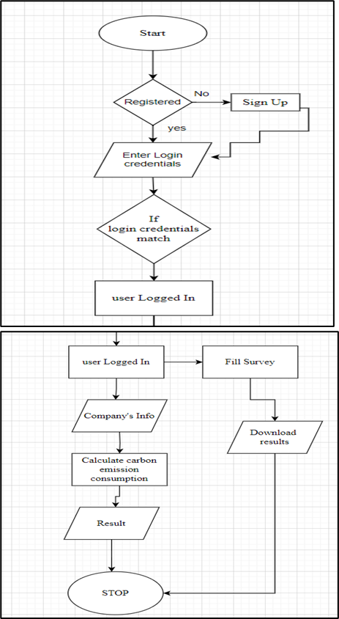

Fig1: Architecture Design

### 4.3 Process Design

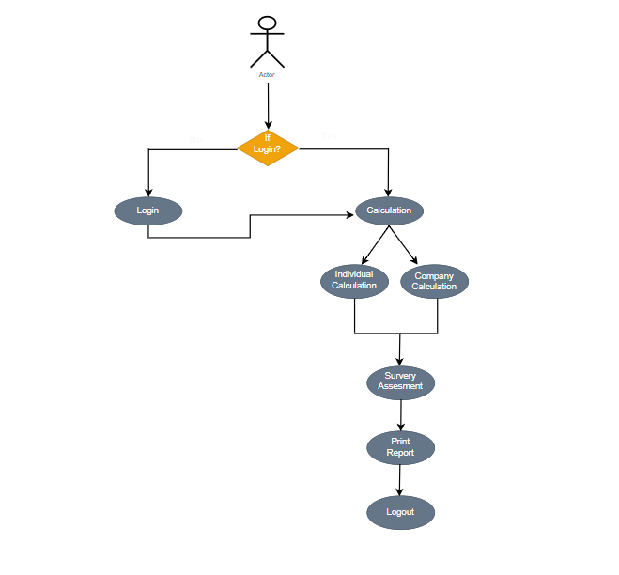

Fig2: Process Design

### 4.4 Methodology Applied and Algorithms

##### User Registration and Login:

Algorithm:

1. User navigates to the carboNeutral website.
2. User navigates to home page.
3. User clicks on the "Signup" button.
4. User provides necessary information (name, email, password, etc.).
5. The system validates the information and creates a user account.
6. User is redirected to the login page.

##### For Calculating:

Algorithm:

1. After logging in, the user is directed to the dashboard.
2. The system displays home page and option for calculation
3. User navigates to calculation page
4. User provides the details necessary for calculation
5. User clicks on the “calculate” button
6. User gets the result.

##### Factors:

Algorithm:

1. When users calculates there carbon emissions.
2. The system displays an option for factors
3. User naviagets to factors page
4. User can read the given information

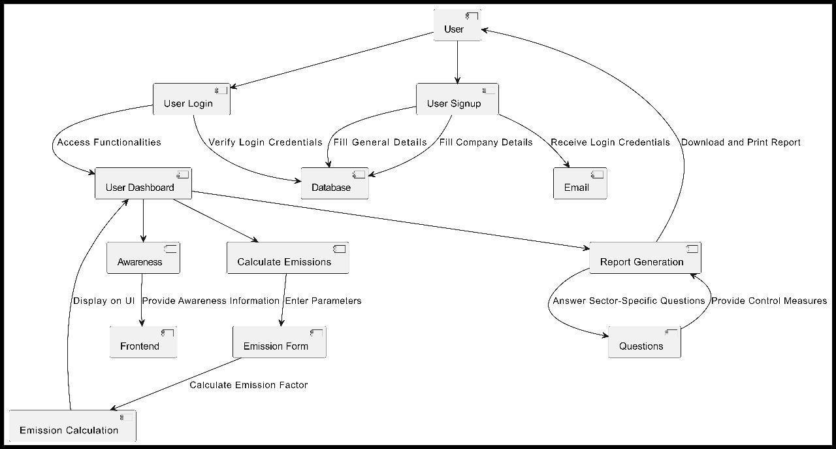

Fig3: Methodology Applied

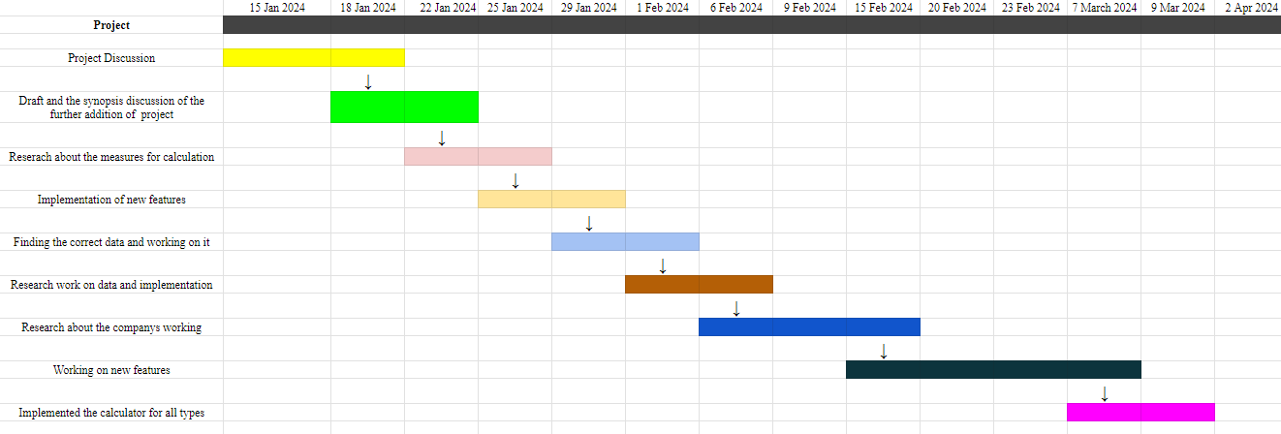

Fig4: Gantt Chart

**5. Testing of the proposed system**

**5.1 Introduction to testing**

Testing on the website **Carboneutral** is aimed at ensuring the functionality, reliability, and accuracy of its features related to carbon footprint calculation and assessment. The testing process involves various types of tests to validate different aspects of the website's performance.

**5.2 Types of tests Considered**

Certainly! Let's delve deeper into the types of testing considered for the website **Carboneutral**

**Functional Testing:** Functional testing evaluates the functionality of the website by verifying that each function performs as expected. It ensures that the website's features, such as user registration, carbon footprint calculation, company assessment, and questionnaire generation, work correctly.

**Objective:** To validate that the website functions according to its specifications and meets user requirements.

**Examples:**

1. Verifying that users can register successfully as individuals or companies.

2. Testing the accuracy of carbon footprint calculations for both individuals and companies.

3. Ensuring that assessment reports are generated accurately based on questionnaire responses.

**Usability Testing:** Usability testing focuses on assessing how user-friendly the website is. It aims to ensure that users can easily navigate through the website, understand its features, and accomplish their tasks efficiently.

**Objective:** To identify any usability issues and improve the overall user experience.

**Examples:**

1. Checking the clarity and intuitiveness of user interface elements during the registration process.

1. Assessing the ease of inputting data for carbon footprint calculation.

3. Verifying that assessment reports are presented in a clear and understandable format.

**5.3 Various test case scenarios considered:**

1. **Register User/Company:**

**Test Case 1**: Verify that users can register successfully as individuals or companies.

**Test Case 2**: Check for validation of required fields during registration.

**Test Case 3**: Ensure that unique usernames and email addresses are enforced.

1. **Individual Carbon Footprint Calculation:**

**Test Case 4:** Validate the accuracy of fuel and electricity consumption calculations.

**Test Case 5:** Test the handling of different units of measurement for inputs.

**Test Case 6:** Verify that the calculated carbon footprint is displayed accurately to the user.

1. **Company Calculation:**

**Test Case 7:** Ensure that company-specific parameters like water wastage, transportation, and energy consumption are accurately calculated.

**Test Case 8:** Validate the aggregation of data from various departments or branches within a company.

**Test Case 9:** Check the generation of comprehensive reports for companies, including recommendations for reducing carbon footprint.

1. **Take Assessment:**

**Test Case 10:** Verify the generation of questionnaires with relevant questions based on user input.

**Test Case 11:** Test the submission process of completed questionnaires.

**Test Case 12:** Ensure that assessment reports are generated accurately based on questionnaire responses.

**5.4. Inference drawn from the test cases**

**Based on the execution of the test cases, the following inferences can be drawn:**

The registration process functions smoothly, ensuring that users can sign up without encountering errors.Carbon footprint calculations, both for individuals and companies, are accurate and based on reliable data inputs. The questionnaire generation and assessment processes are effective in providing users with insights into their carbon footprint and recommendations for improvement. Overall, the website **Carboneutral** performs well in fulfilling its objectives of helping users understand and reduce their carbon footprint effectively.

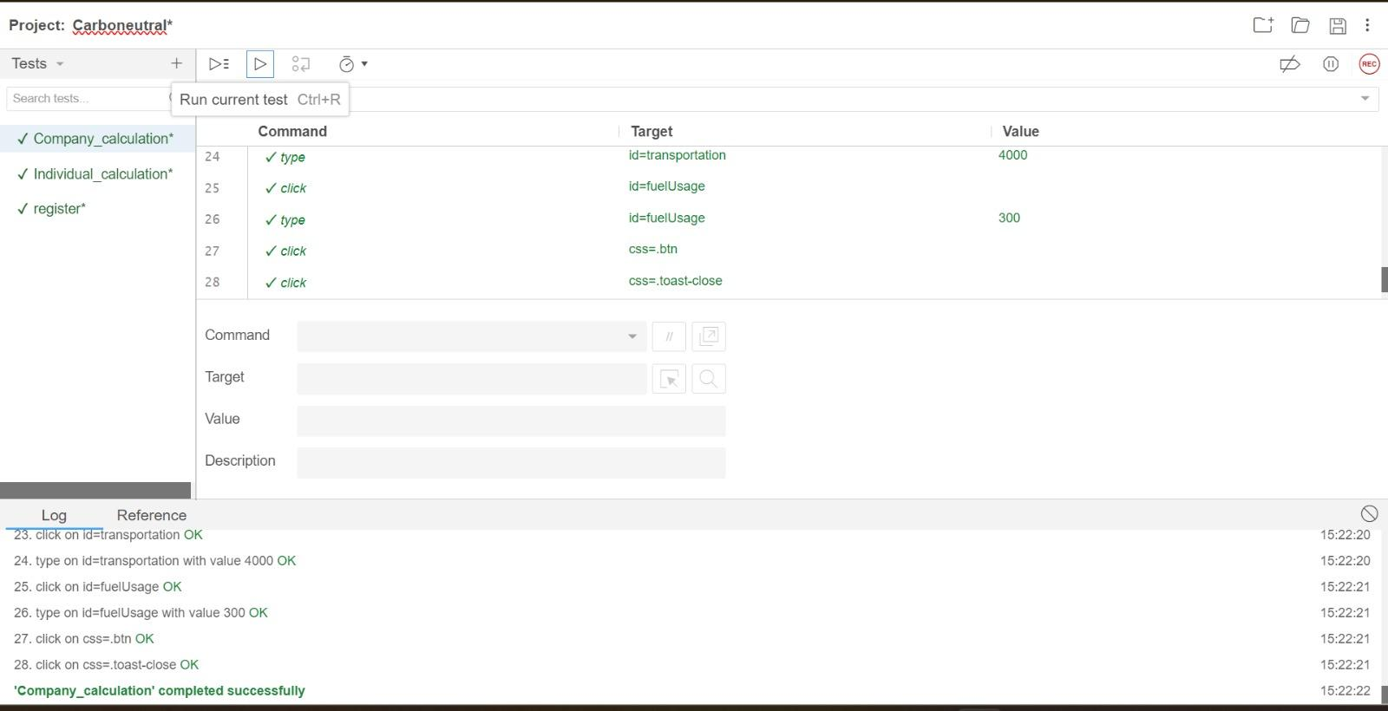

Fig5: Test Case 1

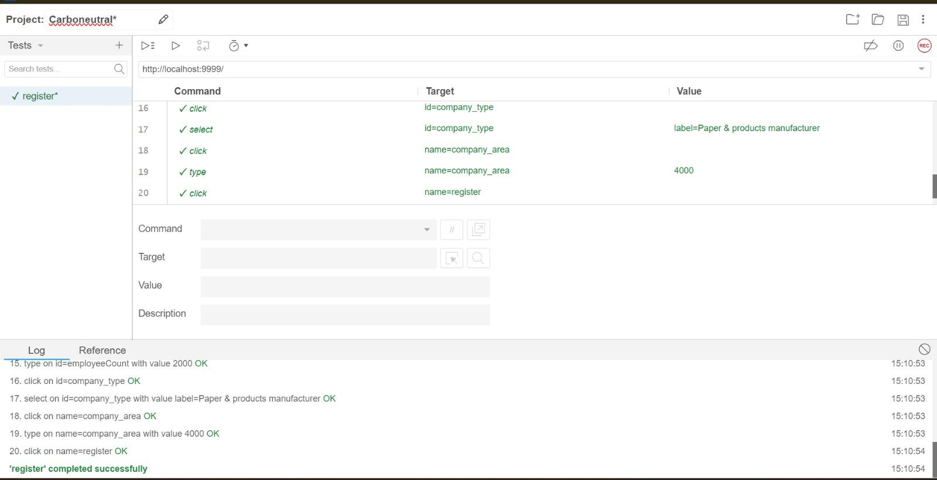

Fig6: Test Case 2

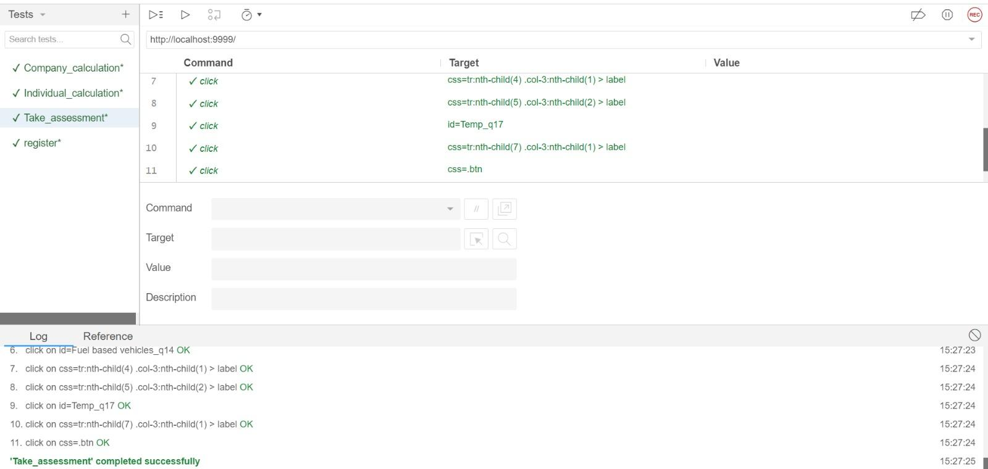

Fig7: Test Case 3

**6. Implementation**

##### Home Page



Fig8: Home Page

**Registration Page**

Fig9: Registration Page

##### Login Page



Fig10: Login Page

**Profile Page**

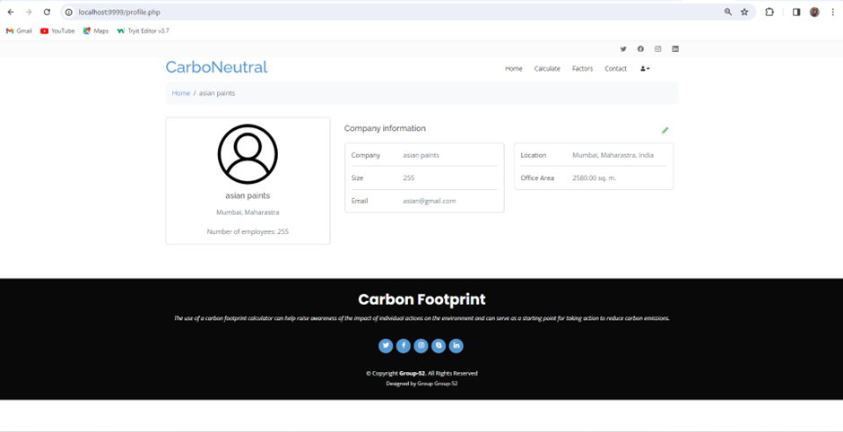

Fig11: Profile Page

**Company Co2 Calculator Page**

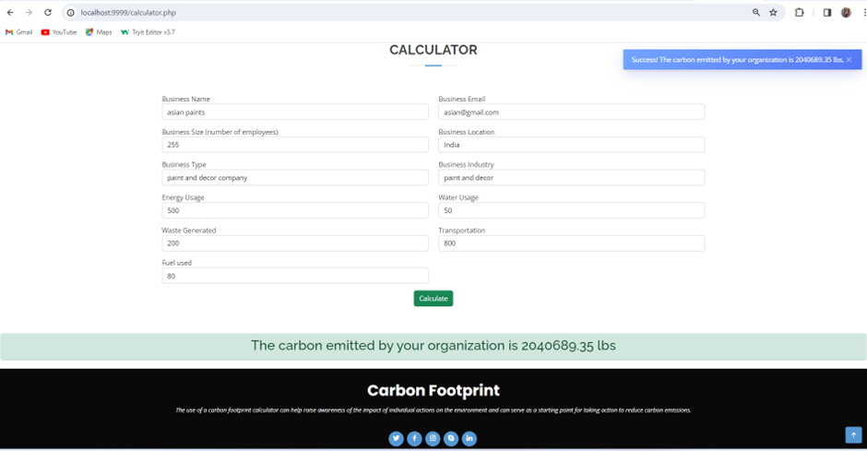

Fig12: Company co2 Calculator Page

##### Assessments Page

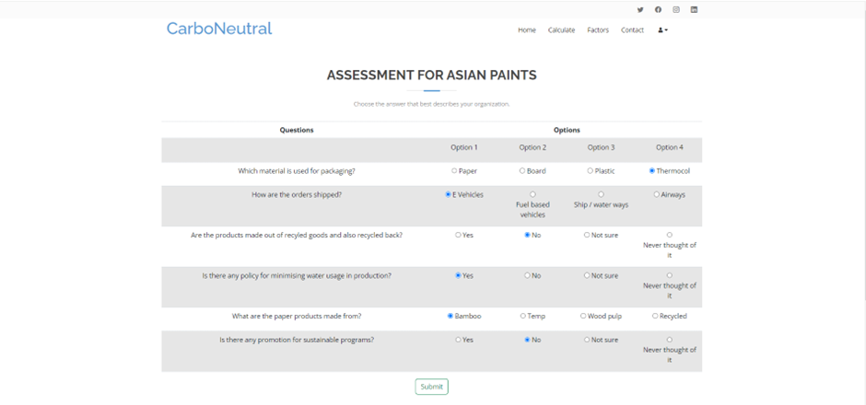

Fig13: Assessments Page

**Assessments Output**

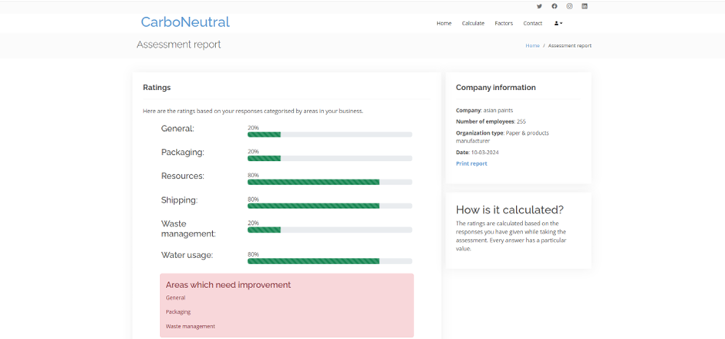 \

Fig14: Assessment Output

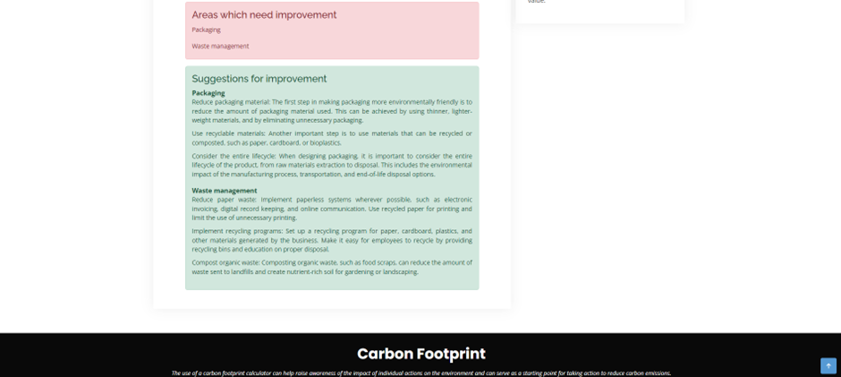

Fig15: Suggestions and improvements

### Assessments Report

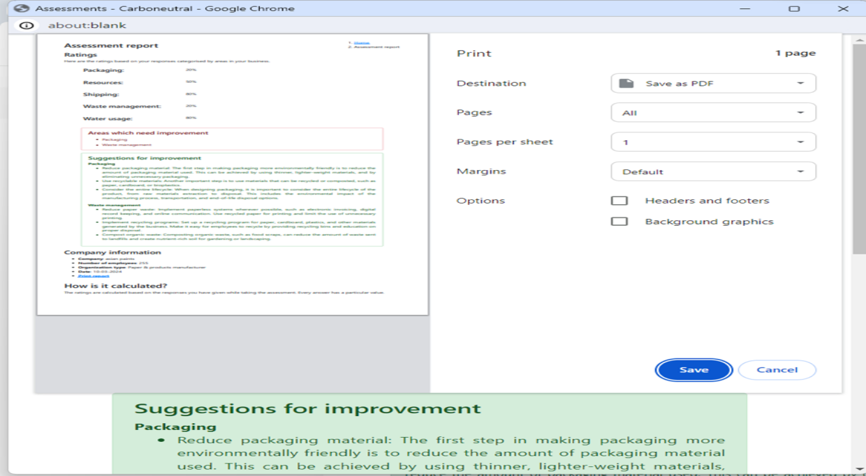

Fig16: Assessments Report

**Fuel Co2 Calculator**

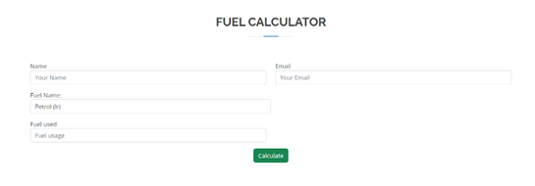

Fig17: Fuel Co2 Calculator

**Electricity Co2 Calculator**

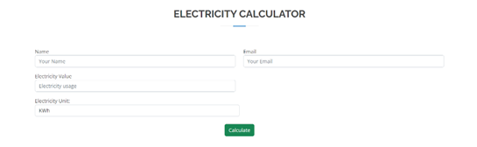

Fig18: Electricity Co2 Calculator

**7. Conclusion**

### 7.1 Conclusion

The conclusion drawn from this concept is clear that humanity must take immediate and sustained action to mitigate the escalating impacts of climate change. The measure of our individual and collective environmental impact, the carbon footprint, serves as a stark reminder of the consequences of our choices and activities. It underscores the critical need to transition towards sustainable practices, reduce emissions, and embrace renewable technologies. The imperative is not only to safeguard our planet for future generations but also to address the pressing social, economic, and environmental challenges that arise from a changing climate. Through concerted efforts, global cooperation, and a shared commitment to sustainability, we have the power to forge a more resilient and harmonious future. The journey towards a lower, more sustainable carbon footprint is not only a responsibility but an opportunity to usher in a new era of environmental consciousness, innovation, and a brighter, more sustainable future for all.

Here are some of the key benefits of using carboNeutral:

* + **Identify emission hotspots:** A carbon footprint tool can help you identify the areas of your business or personal life that are generating the most emissions. This information can be used to develop targeted reduction strategies.
  + **Make informed decisions:** A carbon footprint tool can help you to make more informed decisions about your business practices and personal choices.
  + **Improve your reputation:** Many businesses and individuals are now looking for ways to reduce their environmental impact. Using a carbon footprint tool to demonstrate your commitment to sustainability can improve your reputation and attract new customers and partners.
  + **Sustainability reporting:** Many businesses now produce sustainability reports that disclose their environmental performance. A carbon footprint tool can be used to collect the data needed for these reports.
  + **Innovation and Technological Adoption:** Pursuing carbon reduction goals can drive innovation and lead to the adoption of cleaner, more efficient technologies. This can have positive ripple effects on the broader economy.
  + **Climate Resilience:** Taking action to reduce carbon emissions contributes to global efforts to combat climate change, ultimately contributing to a more stable and resilient planet.

### 7.2 Future Work

Carbon calculators may be improved in the future by utilizing more accurate data sources and streamlining calculating techniques to increase accuracy. A more thorough picture of carbon sources and sinks could be provided by integration with GPS data, satellite images, and remote sensing technologies, enabling more precise evaluations of the carbon footprints of individuals and organizations. Furthermore, improvements in data science methods may make it possible to identify subtle elements affecting carbon emissions, which could result in more individualized suggestions for emission reduction plans. Furthermore, greater usability and accessibility via web and mobile applications may encourage wider use and involvement, enhancing the influence of carbon calculators in encouraging sustainable practices and reducing climate change.

### 

### References

[1] R Rahul; J Selvakumar; R Pradip Kumar; S Krishnaprabha, “A Study of Carbon Footprint in an Educational Institution in India”, Conference at Hyderabad, India.

[2] Parth Wadke, Vivek Gonal, Divesh Watwani, Prithviraj Chavan, Sunita Sahu, "Carbon Footprint: Causes,

Impacts and Sector-Wise Survey",Conference at Navi Mumbai, India

[3] Babis Theodoulidis, David Diaz, Mohamed Zaki "Carbon Footprint Innovation through Environmental Information Management",Conference at San Jose, CA, USA.

[4] I.A. Stepanovskaya, "Reduction of Carbon Footprint: Digital Management Strategies", Conference at Moscow, Russian Federation.

[5] Tan Chun Ho, Sim Chong Keat Mohd Zubir Mat Jafri and Lim Hwee San, "A Prediction Model for CO2 Emission From Manufacturing Industry and Construction in Malaysia", International Conference on Space Science and Communication,2015.

[6] https://www.sciencedirect.com/science/article/abs/pii/S0959652619331154

[7] <https://www.thelancet.com/journals/lancet/article/PIIS01406736(09)61759-1>

Carbo Neutral

# *Priti Joshi1, Dhara Bhatia2, Chiraag Chugh3, Sonnal Katara4, Neha Lotwani5*

Mrs. Priti Joshi

Computer Engineering Department,

V.E.S. Institute of Technology,

Chembur, Mumbai, India

[priti.joshi@ves.ac.in](mailto:priti.joshi@ves.ac.in)

Dhara Bhatia

Computer Engineering Department,

V.E.S. Institute of Technology,

Chembur, Mumbai, India

[d2021.dhara.bhatia@ves.ac.in](mailto:d2021.dhara.bhatia@ves.ac.in)

Chiraag Chugh

Computer Engineering Department,

V.E.S. Institute of Technology,

Chembur, Mumbai, India

[d2021.chiraag.chugh@ves.ac.in](mailto:d2021.chiraag.chugh@ves.ac.in)

Sonnal Katara

Computer Engineering Department,

V.E.S. Institute of Technology,

Chembur, Mumbai, India

[d2021.sonnal.katara@ves.ac.in](mailto:d2021.sonnal.katara@ves.ac.in)

Neha Lotwani

Computer Engineering Department,

V.E.S. Institute of Technology,

Chembur, Mumbai, India

[d2021.neha.lotwani@ves.ac.in](mailto:d2021.neha.lotwani@ves.ac.in)

---------------------------------------------------------------------***---------------------------------------------------------------------

***Abstract –* The surge in transportation, rapid population growth, and industrialization has led to a notable escalation in atmospheric carbon levels. While transportation, industrialization, and technological advancements have bestowed benefits upon modern society, they concurrently pose significant concerns by contributing to carbon footprint generation.**

**A carbon footprint serves as a metric to quantify the total greenhouse gas emissions, predominantly carbon dioxide, attributable to individuals, organizations, or activities within a specified timeframe. This metric, typically expressed in metric tons of carbon dioxide equivalent (CO2e), underscores the environmental impact of human actions.**

**The potential environmental impact of the digital technologies themselves. While digital management strategies offer promising avenues for carbon footprint reduction, the manufacturing, operation, and disposal of digital devices and infrastructure also contribute to carbon emissions.**

## *Keywords: Survey Assessment, Company and Individual Calculator, Print Report.*

1. **INTRODUCTION**

A carbon calculator is a digital tool designed to quantify an individual's or organization's carbon footprint by assessing their energy consumption, transportation habits, and other activities contributing to greenhouse gas emissions.

The CarboNeutral application represents a proactive solution aimed at assisting organizations in curtailing their carbon footprints, thereby fostering an environmentally friendly business ecosystem.[1]

It helps you understand how much you affect the environment, whether you're a person or a group like a company. This knowledge helps you find ways to do better for the environment and make changes to be more sustainable.

The calculation and mitigation of one's carbon footprint have emerged as crucial elements in fostering environmental consciousness and promoting sustainable living practices.[3]

## *Aim*

The aim of a carbon calculator is to raise awareness about carbon emissions and their environmental impact. By quantifying carbon footprints, the calculator encourages individuals and organizations to adopt eco-friendly behaviors, reduce energy consumption, and mitigate climate change.

* 1. ***Objectives***
* Quantify carbon emissions: The primary objective is to accurately assess carbon footprints by analyzing energy usage, transportation, and other activities.
* Raise awareness: Educate users about the environmental consequences of their actions and encourage behavioral changes to reduce carbon emissions.
* Facilitate decision-making: Provide users with actionable insights and suggestions to help them make informed choices that minimize their carbon footprint.

## *Features*

* Real Time Calculation
* User Friendly Interface
* Factors of carbon emission
* Survey Assessment
* Report Generation

1. **LITERATURE SURVEY**

A Study of Carbon Footprint in an Educational Institution in India likely examines the carbon footprint of a specific educational institution in India, focusing on aspects such as energy usage, waste management, transportation, and overall environmental impact. It probably aims to provide insights into the institution's contribution to carbon emissions and suggests potential strategies for reducing its environmental footprint.-302

**Carbon Footprint:** Causes, Impacts and Sector-Wise Survey likely provides an overview of the causes and impacts of carbon footprint, along with a sector-wise survey to analyze carbon emissions across various industries or sectors. It might explore the sources of carbon emissions, their environmental and economic impacts, and strategies for mitigation.

Carbon Footprint Innovation through Environmental Information Management" likely explores the role of environmental information management in fostering innovation to reduce carbon footprint. It may discuss how organizations can utilize data and information management strategies to identify opportunities for carbon footprint reduction, optimize resource usage, and implement sustainable practices. The paper might also highlight case studies or examples of innovative approaches to carbon footprint reduction driven by effective environmental information management.

**Reduction of Carbon Footprint:** Digital Management Strategies" likely examines the use of digital management strategies to reduce carbon footprint. It probably discusses how digital technologies, such as data analytics, artificial intelligence, and Internet of Things (IoT), can be leveraged to optimize resource usage, enhance energy efficiency, and mitigate carbon emissions in various sectors. The paper may also explore case studies or examples of successful implementation of digital management strategies for carbon footprint reduction.

A Prediction Model for CO2 Emission from Manufacturing Industry and Construction in Malaysia" likely presents a model aimed at forecasting carbon dioxide emissions from the manufacturing industry and construction sector in Malaysia. It probably involves analyzing various factors such as industrial activity, energy consumption, production processes, and construction projects to develop a predictive tool for estimating CO2 emissions.

Enhancing User Experience in Carbon Footprint Calculators: A Comparative Analysis of Features and Functionality by Patel and Kumar (2021)This research paper presents a specialized carbon footprint calculator tailored to the needs of businesses and organizations. Incorporates advanced functionalities for assessing emissions across various operational activities.

The study emphasizes the importance of survey assessments in validating calculator accuracy and enhancing user engagement. It also discusses the potential for integrating individual-level carbon footprint assessments within company-level sustainability initiatives to promote holistic environmental responsibility

| **AUTHORS** | **PAPER** | **PROBLEM** |
| --- | --- | --- |
| R-Rahul,J Selvakumar,R.Pradip Kumar,S Krishnaprabha | “A Study of Carbon Footprint in an Educational Institution in India” | Availability and accuracy of data related to energy consumption, waste generation, and other carbon footprint components can be a significant limitation. In some cases, data may be estimated or based on rough averages, which can introduce uncertainty. |
| Parth Wadke, Vivek Gonal, Divesh Watwani | "Carbon Footprint: Causes, Impacts,and Sector-Wise Survey" | Complex systems like institutions can be challenging to model accurately. Assumptions and simplifications may be necessary, but they can introduce uncertainty and potentially skew the results. |
| I.A. Stepanovskaya | "Reduction,of Carbon Footprint:-Digital Management Strategies" | Without comparative data from similar institutions, it may be challenging to assess how the institution's carbon footprint compares to peers or industry |
| Babis Theodoulidis, David Diaz, Mohamed Zaki | "Carbon Footprint Innovation through Environmental Information Management" | The climate and region in which the institution is located can have a substantial impact. For instance, a location with a milder climate may have different energy consumption patterns compared to one with extreme temperatures. |

1. **ARCHITECTURE**
2. ***Problem Statement/ Definition***

Building a Carbo-Neutral Application for Environmental Sustainability. The carbon footprint revolves around the escalating levels of greenhouse gas emissions and their profound impact on the Earth's climate system. Things people do, like burning fossil fuels for energy, cutting down trees, and running factories, have caused a big increase in gases like carbon dioxide in the air warm up the Earth.

This surge is driving global temperatures to unprecedented heights, resulting in erratic weather patterns, rising sea levels, and disruptions to ecosystems worldwide. The lack of consideration for the carbon footprint associated with virtual or online learning platforms. With the increasing prevalence of digital education due to factors like the COVID-19 pandemic and advancements in technology, there's a significant carbon footprint associated with the use of digital devices, data centers, and internet infrastructure [1].

Our mission is to develop an innovative Carbo-Neutral application to combat carbon emissions and foster eco-friendly practices. Limited focus on emerging sectors or technologies with potential for significant carbon footprint reduction. With advancements in renewable energy, sustainable agriculture, transportation, and other sectors, there are new opportunities to reduce carbon emissions [2]. This application will serve as a crucial tool for individuals and organizations to understand and reduce their carbon footprint across key areas such as transportation, energy usage, and dietary habits. Through comprehensive ratings and analytics, users will gain insights into the environmental impact of their daily activities. By quantifying carbon emissions and providing personalized recommendations, the application will empower users to make informed decisions that align with their commitment to sustainability.

## *B. Proposed Architecture*

First, the mentor picked a project called CarboNeutral. Then, our team talked about which software to use, how to design it, what features it should have, and many other details for our project.

We started to:

* Collect and analyze data on the topic
* Prepared the flowchart
* Started on the code according to the algorithm and flowchart
* Compiled the code and eliminated any errors
* Compiled the code again and checked the output
* Presenting the project to the guide/mentor for confirmation
* Edited and revised the project

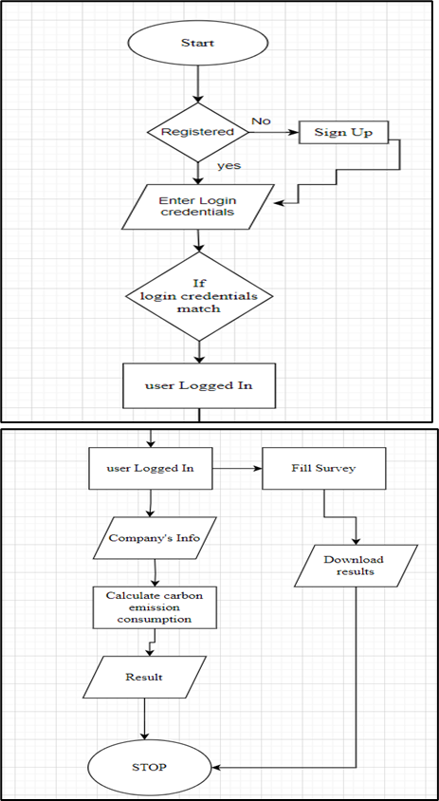

Fig1: Flow Chart



Fig2: Use case Diagram

1. **METHODOLOGY**

* **Analysis of Previous Papers:**

Conducted a thorough review and analysis of existing research papers and studies related to carbon emissions, environmental impact assessments, and sustainability practices. This helped in gaining insights into current methodologies, trends, and challenges in carbon emission calculations and mitigation strategies.

* **Study of Terms and Criteria for CO2 Emission Factors:**

Researched and studied the various terms, methodologies, and criteria used for calculating CO2 emission factors in different countries and regions. This involved understanding factors such as energy consumption, transportation modes, industrial processes, and renewable energy sources that contribute to carbon emissions.

* **Declaration of Country-Specific Factors for CO2 Emission Calculation:**

Identified and declared specific factors and parameters relevant to each country or region for accurate calculation of CO2 emissions. This included considering factors such as energy production methods, transportation infrastructure, industrial activities, and policy regulations governing carbon emissions.

* **Creation of Surveys for Companies to Generate CO2 Emission Reports:**

Developed comprehensive surveys and assessment tools for companies to collect data on their carbon emissions across various operations and activities. These surveys were designed to capture detailed information on energy usage, transportation practices, waste management, and other factors contributing to carbon footprint.

* **Implementation of Authentication for Company's CO2 Calculations and Reports:**

Implemented robust authentication mechanisms to ensure the accuracy and integrity of company-reported CO2 emissions data. This involved verifying the authenticity of data submissions, validating the identity of participating companies, and safeguarding against fraudulent or misleading information.

* **Development of Individual Calculator for Users to Calculate CO2 Emissions:**

Created user-friendly calculators within the CarbonNeutral app for individuals to estimate their personal carbon footprint based on various factors such as fuel consumption, energy usage, and lifestyle choices. These calculators provided personalized insights and recommendations for reducing carbon emissions through sustainable practices.

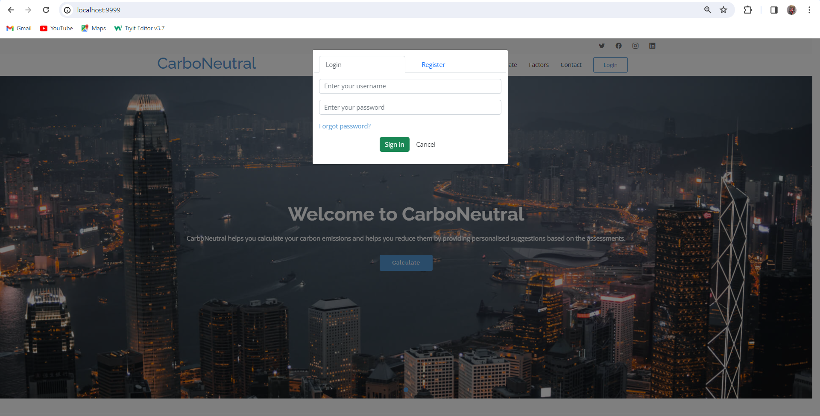

Fig 3.1 Login Page

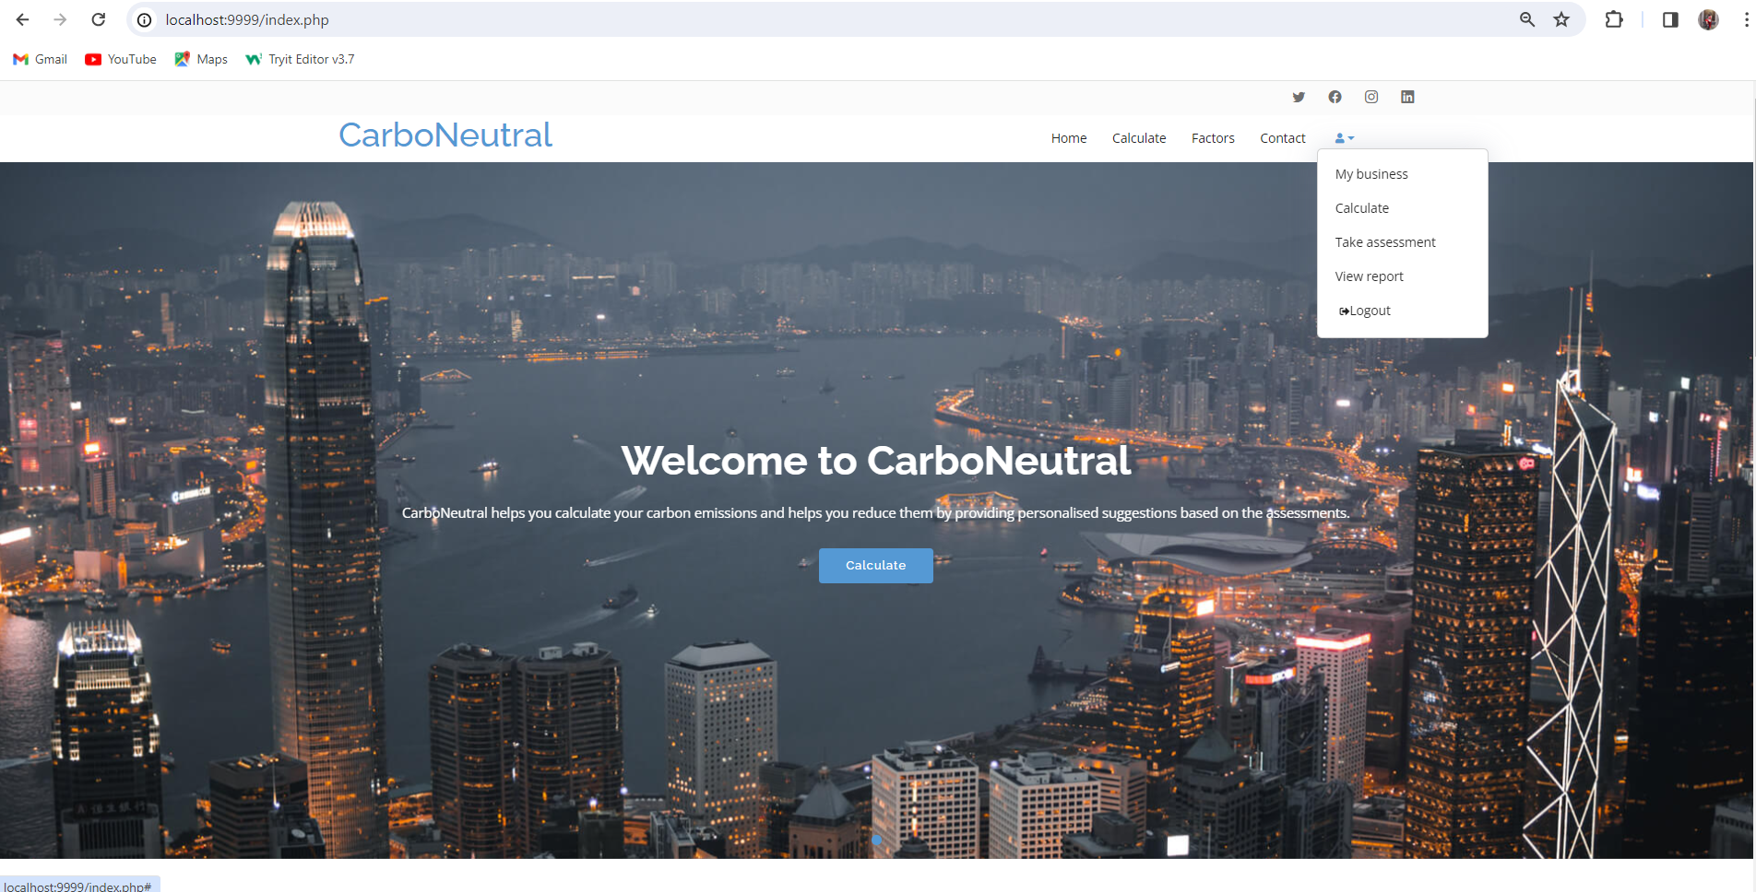

Fig 3.2 Home Page

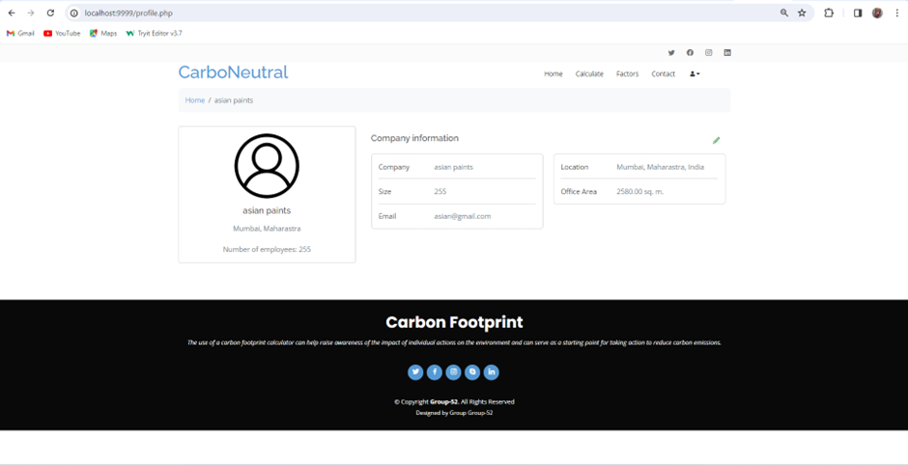

Fig 3.3 Profile Page

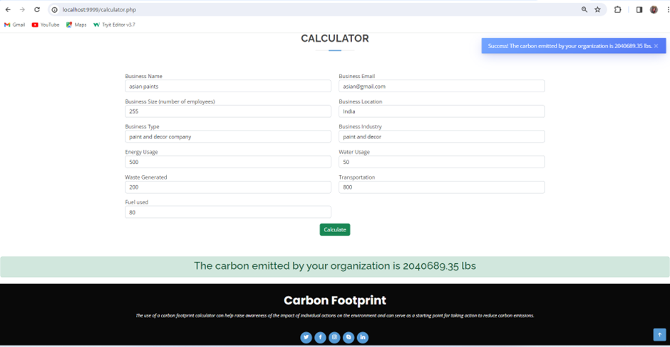

Fig 3.4 Company Co2 Calculator

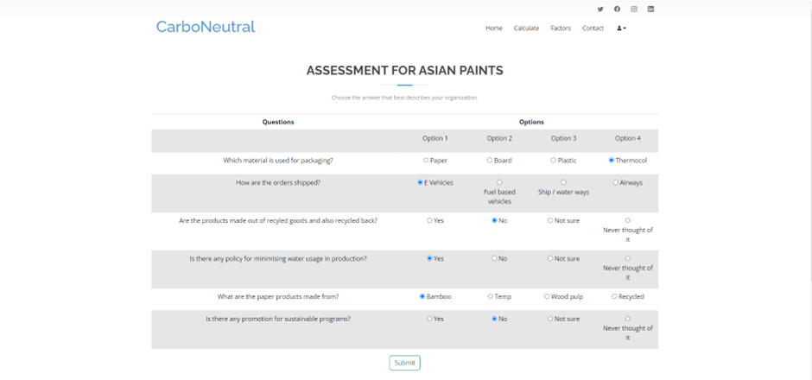

Fig 3.5 Assessments Page

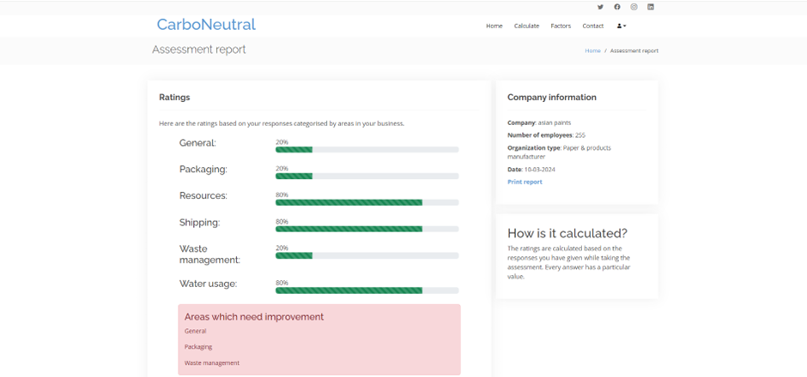

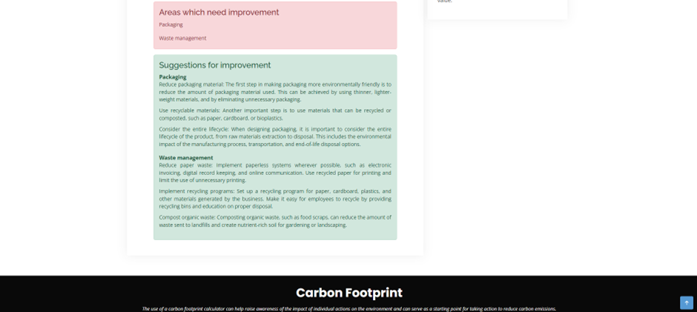

Fig 3.6 Assessments Output

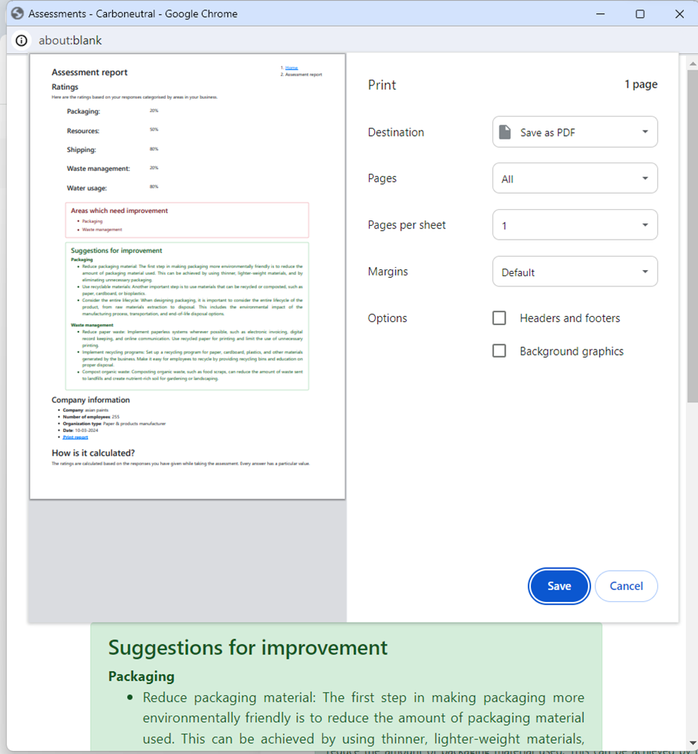

Fig 3.7 Assessments Report

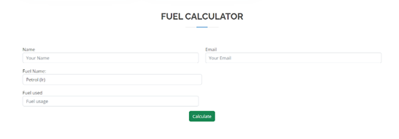

Fig 3.8 Fuel Co2 Calculator

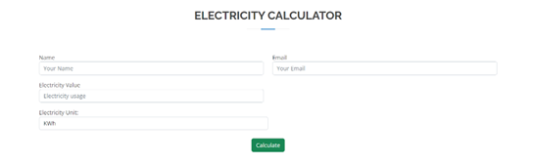

Fig 3.9 Electricity Co2 Calculator

1. **ACKNOWLEDGEMENTS**

We want to extend our heartfelt gratitude to everyone who helped and supported us in planning our project smoothly and successfully.

Special thanks to Mrs. Priti Joshi, a faculty member of Computer Engineering at V.E.S. Institute of Technology, for her guidance. We sincerely appreciate her for generously sharing her time and knowledge, which helped us grasp the planning process and ensured a systematic approach to our project on time.

1. **CONCLUSION**

In conclusion, the Carbo-Neutral Application stands as a beacon of hope in our collective effort to combat climate change and create a more sustainable world. While the project shows immense promise, it's crucial to address several key areas to fully unlock its potential. Firstly, enhancing data accuracy and reliability is paramount. By ensuring that our calculations are precise and up-to-date, we can provide users with truly meaningful insights into their carbon footprint. Encouraging honest survey responses and expanding the scope of factors considered will further enrich the application's capabilities. We can offer tailored recommendations and inspire meaningful behavior change. Lastly, prioritizing accessibility and adoption ensures that our application reaches and empowers users from all walks of life. By designing a user-friendly interface and providing multilingual support, we can ensure that sustainability is truly for everyone. In essence, by addressing these key areas, the Carbon-Neutral Application has the potential to catalyze a global movement towards a greener, more sustainable future.

Having this semester dedicated to planning and organizing things systematically made it easier for us to plan and allowed us to have a clear strategic process.

1. **FUTURE SCOPE**

Carbon calculators may be improved in the future by utilizing more accurate data sources and streamlining calculating techniques to increase accuracy. A more thorough picture of carbon sources and sinks could be provided by integration with GPS data, satellite images, and remote sensing technologies, enabling more precise evaluations of the carbon footprints of individuals and organizations. Furthermore, improvements in data science methods may make it possible to identify subtle elements affecting carbon emissions, which could result in more individualized suggestions for emission reduction plans. Furthermore, greater usability and accessibility via web and mobile applications may encourage wider use and involvement, enhancing the influence of carbon calculators in encouraging sustainable practices and reducing climate change

1. **REFERENCES**
2. R Rahul; J Selvakumar; R Pradip Kumar; S Krishnaprabha, “A Study of Carbon Footprint in an Educational Institution in India”, Conference at Hyderabad, India.
3. Parth Wadke, Vivek Gonal, Divesh Watwani, Prithviraj Chavan, Sunita Sahu, "Carbon Footprint: Causes, Impacts and Sector-Wise Survey”, Conference at Navi Mumbai, India
4. Babis Theodoulidis, David Diaz, Mohamed Zaki "Carbon Footprint Innovation through Environmental Information Management”, Conference at San Jose, CA, USA.
5. I.A. Stepanovskaya, "Reduction of Carbon Footprint: Digital Management Strategies' ', Conference at Moscow, Russian Federation.

[5] Tan Chun Ho, Sim Chong Keat Mohd Zubir Mat Jafri and Lim Hwee San, "A Prediction Model for CO2 Emission From Manufacturing Industry and Construction in Malaysia", International Conference on Space Science and Communication,2015.

.

**Plagiarism Report**

## 

## Project Review Sheet

**Review 1:**

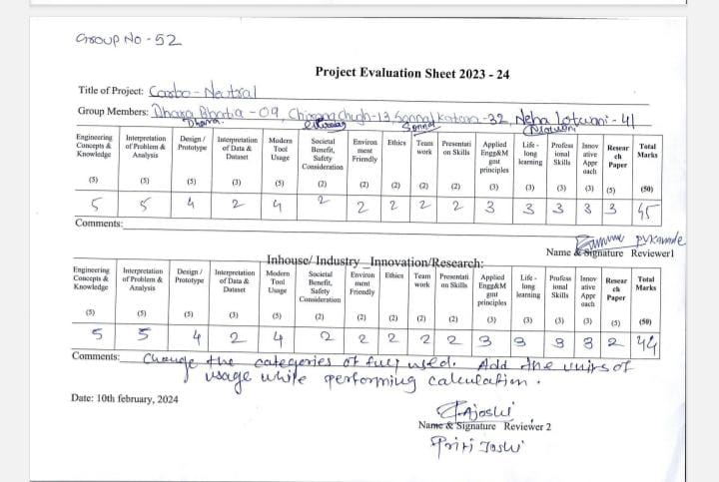

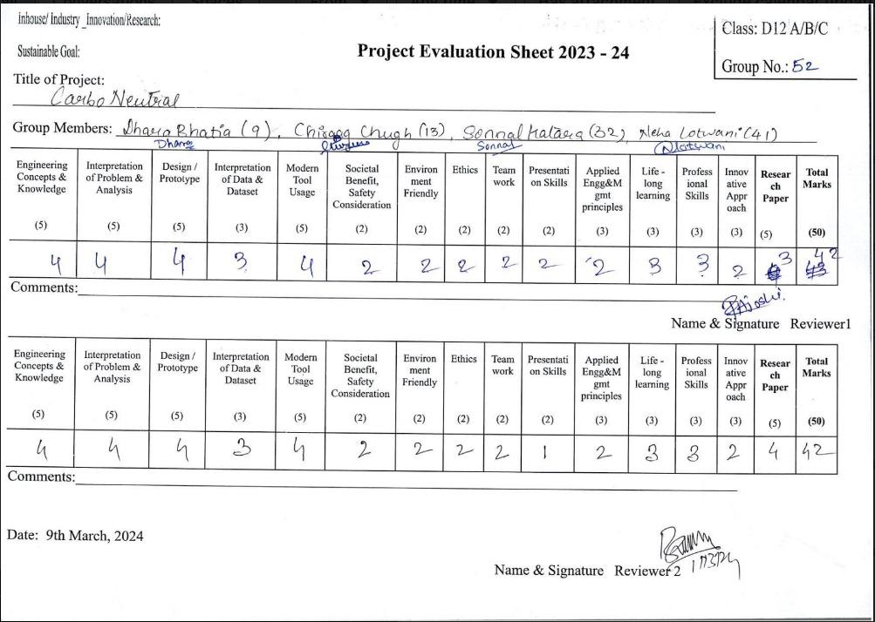

**Review 2:**